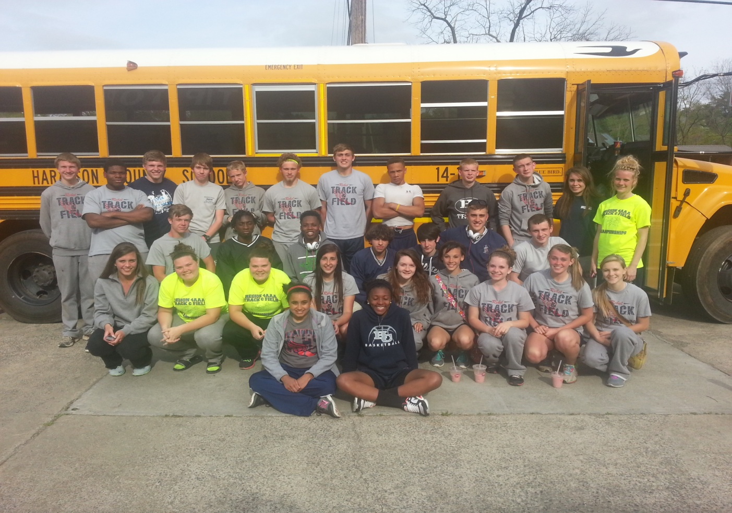
Congratulations to the Boys and Girls Track teams who competed in the 4AAA Region Track Meet. Boys finished Third overall and Girls 5th!
Region winners moving on to Sectionals on April 26th include:

Boys:
Tyler Carnes 1st in Discus
Tim Dunbar 2nd in Shot Put
Kane Sewell 2nd in Long Jump
Brandon Owens 4th in High Jump

Girls:
Sarah Flowers 1st in Pole Vault
Madison Brooks 2nd in Discus
Morgan Brooks 4th in Discus
Jada Ross 4th in 200 Meters
Savannah Ross 4th in the 1600 Meters and 4th in the 800 Meters
Girls 4X400 (Sarah Flowers, Jada Ross, Jaylen Sewell, and Savannah Ross) 4th

